Jacob Stovall - 1206636713

Christopher Mendez - 1205435864

Aidan Spies

**Project 2 – Image Retrieval and Embedding**

Image Retrieval Testing Results

For the first part of the project, we evaluated the image features and distance functions by using a ranking system to rank the top ten results of each algorithm and feature (10 being the best match to get and 1 being the worst). We then summed the rankings of matches that were of the same evolution line or type for each individual algorithm or feature (if there was more than one type of evolution or more than one Pokémon of the same type, then both scores would be attributed to the total sum).

General Statistics (Looking at Extracted Features and Distance Functions):

|  |  |  |
| --- | --- | --- |
| **Image Feature** | **Sum of all Evolution Rank** | **Sum of all Matching Type Rank** |
| Average Color Pixel | 42 | 518 |
| Spatial Grid of Average Pixel Color | 25 | 364 |
| Color Histograms | 38 | 363 |
| Edge Detection-Image Segmentation | 29 | 357 |

|  |  |  |
| --- | --- | --- |
| **Distance Function** | **Sum of all Evolution Rank** | **Sum of all Matching Type Rank** |
| SSD | 58 | 778 |
| Angle Between Vectors | 76 | 824 |

To see our graphs for this data, go to Appendix I – Graphs of Results, and to see the screenshots of the outputs, go to Appendix II – Image Retrieval Screenshots.

All image features used have their pros and cons when trying to retrieve images. The advantage of average pixel color is that it is very simple (since it will only output an array of 3 numbers). In addition, it was the most successful feature in our testing because a lot of the evolution lines and typing use a lot of the same colors. However, the disadvantage is that average color does not give us any insight on the shape of the subject, it can be too simplistic when dealing with complex images, and it can be skewed based on background colors (for example, MATLAB makes the PNG backgrounds black by default). Spatial Grid of Average Pixel Color improves upon Average Pixel Color by giving us more data points to work with and giving a better idea of all the colors in the image. However, the drawback is that now how the Pokémon’s shape and size can more greatly affect how the distances will be calculated (which is bad if the Pokémon grows a lot over evolutions). Color histograms are useful because they compare the frequency of certain r, g, and b values in an image, but the drawback is that the histogram doesn’t care about how those values end up combining in the image (meaning with 2 completely different color images could somehow end up close if their r, g, and b values have close frequencies). Finally, Edge Detection using a Spatial Grid is useful because it can detect images with similar shapes, but the drawback in our situation is that Pokémon can often change shapes when they evolve (which is why it was one of the least successful features). The other drawback is that in our implementation of the edge detection, we tried to get the whole subject of the image (which sometimes ended up causing issues where the output would just be a black image and thus it wouldn’t properly retrieve the correct image). In addition, when looking at Sum of Squared Distances and Angle Between Vectors, Angle Between Vectors was often more successful at retrieving Pokémon of the same type and/or evolution than Sum of Squared Distances.

The algorithms seemed to work better on Pokémon whose types had a defined color scheme such as grass, bug, water or fire type. The dragon type Pokémon did not work as well with finding their evolution lines or typing since the color scheme is not as universal.

Testing with Other Images



The three images above were used in our database and since the Average Color Pixel and Angle Between Vectors were the best feature and algorithm we used them exclusively for these images. The top ten results are below.







For each image, there was a definite pattern when it comes to the Pokémon Type and even returned a lot of Pokémon from the same evolution lines. The yellow Radiation image returning a lot of Electric and some grass types. The red Mario image only returned fire types and what was interesting was that the top ten returned were all strictly Fire type and not a mix of two types. The green Yoshi image only returned bug and grass type Pokémon which is to be expected since green shows up a lot in both plant life and bugs.

Image Embedding Results

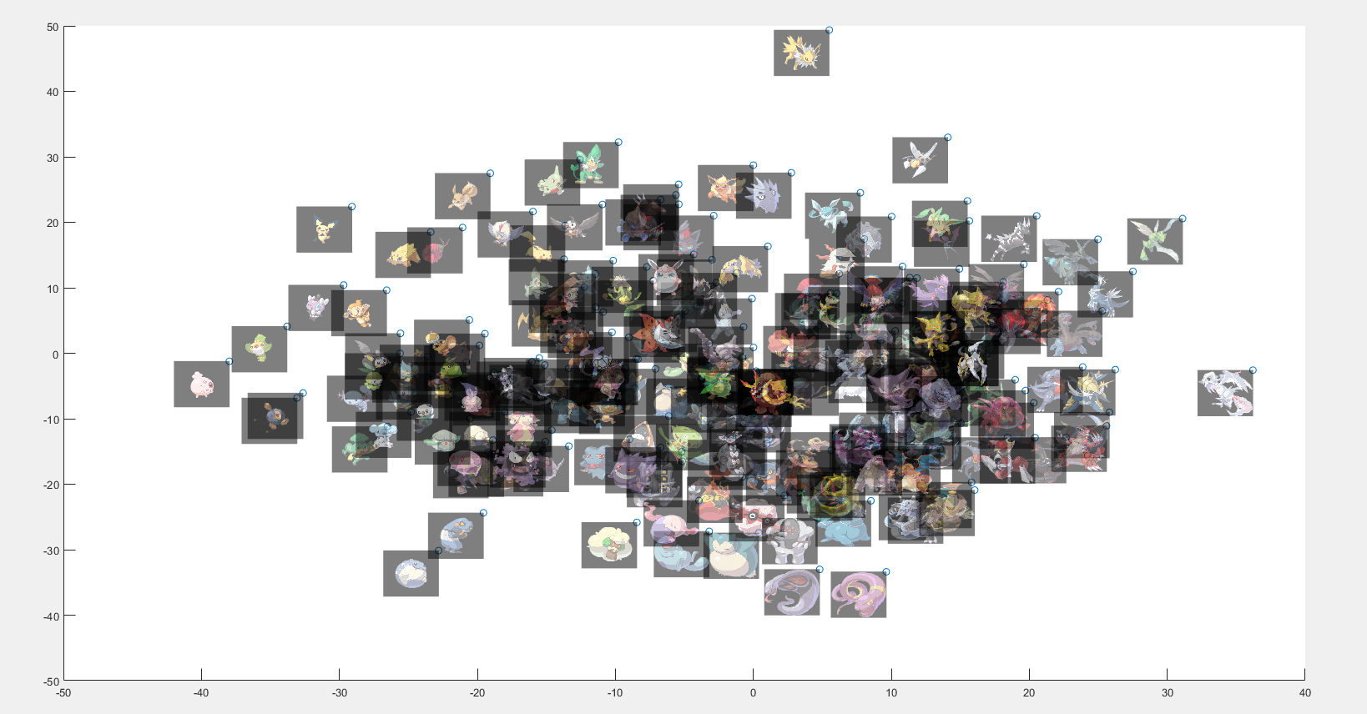

The resulting plot from the Principle Component Analysis was really good. A lot of the Pokémon ended up being near their evolutions (Pikachu and Raichu on the left, Arbok and Ekans near the bottom, Alakazam and Kadabra on the top right of the cluster, etc.). In addition, there’s a bit of a trend where on the left side of the graph there’s a lot of smaller Pokémon, but as you move right, the Pokémon get progressively larger. In addition, the top right of the cluster seems to have a lot of Pokémon with wings. Finally, on the bottom left, there are a bunch of Pokémon with more blobular forms. So, even though there are a few exceptions where evolutions are not grouped together (such as Abra being a bit away from its evolutions), the PCA function did a good job at finding patterns between the designs.

**Appendix I – Graphs of Results**

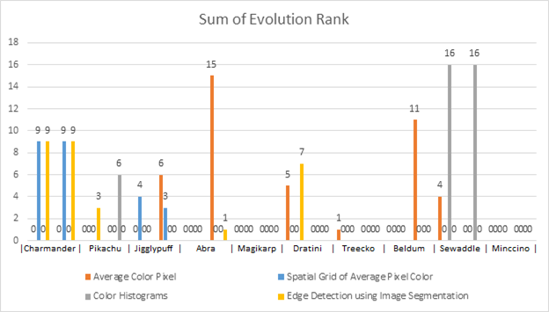

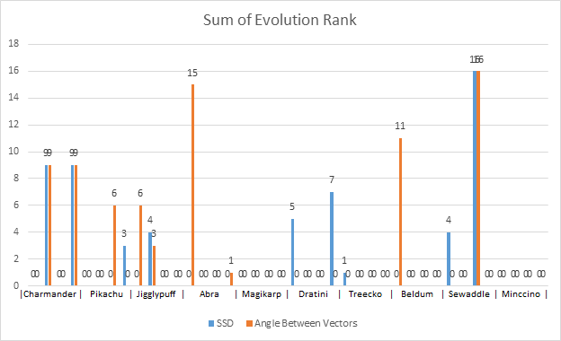

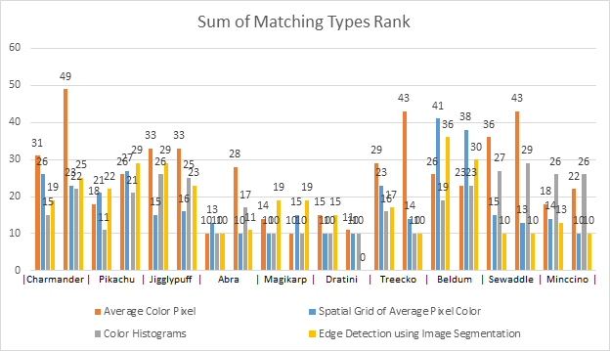

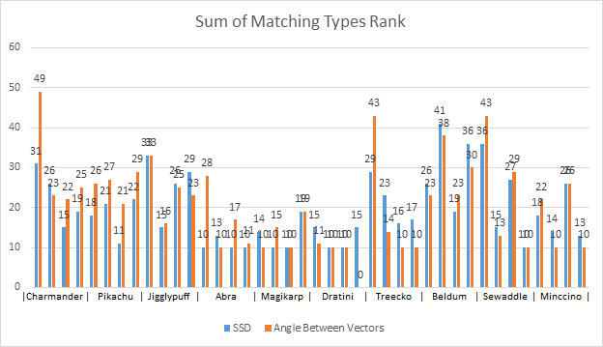

**Appendix II – Image Retrieval Screenshots**

|  |  |
| --- | --- |
| **Algorithm** |  |
| **Average Pixel Color - SSD** |  |
| **Average Pixel Color - Angle Between Vectors** |  |
| **Spatial Grid of Average Pixel Color - SSD** |  |
| **Spatial Grid of Average Pixel Color – Angle Between Vectors** |  |
| **Color Histogram - SSD** |  |
| **Color Histogram – Angle Between Vectors** |  |
| **Edge Dectection with Image Segmentation - SSD** |  |
| **Edge Dectection with Image Segmentation – Angle Between Vectors** |  |

**4.png – Results**

|  |  |
| --- | --- |
| **Algorithm** |  |
| **Average Pixel Color - SSD** |  |
| **Average Pixel Color - Angle Between Vectors** |  |
| **Spatial Grid of Average Pixel Color - SSD** |  |
| **Spatial Grid of Average Pixel Color – Angle Between Vectors** |  |
| **Color Histogram - SSD** |  |
| **Color Histogram – Angle Between Vectors** |  |
| **Edge Dectection with Image Segmentation - SSD** |  |
| **Edge Dectection with Image Segmentation – Angle Between Vectors** |  |

**25.png – Results**

|  |  |
| --- | --- |
| **Algorithm** |  |
| **Average Pixel Color - SSD** |  |
| **Average Pixel Color - Angle Between Vectors** |  |
| **Spatial Grid of Average Pixel Color - SSD** |  |
| **Spatial Grid of Average Pixel Color – Angle Between Vectors** |  |
| **Color Histogram - SSD** |  |
| **Color Histogram – Angle Between Vectors** |  |
| **Edge Dectection with Image Segmentation - SSD** |  |
| **Edge Dectection with Image Segmentation – Angle Between Vectors** |  |

**39.png – Results**

|  |  |
| --- | --- |
| **Algorithm** |  |
| **Average Pixel Color - SSD** |  |
| **Average Pixel Color - Angle Between Vectors** |  |
| **Spatial Grid of Average Pixel Color - SSD** |  |
| **Spatial Grid of Average Pixel Color – Angle Between Vectors** |  |
| **Color Histogram - SSD** |  |
| **Color Histogram – Angle Between Vectors** |  |
| **Edge Dectection with Image Segmentation - SSD** |  |
| **Edge Dectection with Image Segmentation – Angle Between Vectors** |  |

**63.png – Results**

|  |  |
| --- | --- |
| **Algorithm** |  |
| **Average Pixel Color - SSD** |  |
| **Average Pixel Color - Angle Between Vectors** |  |
| **Spatial Grid of Average Pixel Color - SSD** |  |
| **Spatial Grid of Average Pixel Color – Angle Between Vectors** |  |
| **Color Histogram - SSD** |  |
| **Color Histogram – Angle Between Vectors** |  |
| **Edge Dectection with Image Segmentation - SSD** |  |
| **Edge Dectection with Image Segmentation – Angle Between Vectors** |  |

**129.png – Results**

|  |  |
| --- | --- |
| **Algorithm** |  |
| **Average Pixel Color - SSD** |  |
| **Average Pixel Color - Angle Between Vectors** |  |
| **Spatial Grid of Average Pixel Color - SSD** |  |
| **Spatial Grid of Average Pixel Color – Angle Between Vectors** |  |
| **Color Histogram - SSD** |  |
| **Color Histogram – Angle Between Vectors** |  |
| **Edge Dectection with Image Segmentation - SSD** |  |
| **Edge Dectection with Image Segmentation – Angle Between Vectors** |  |

**147.png – Results**

|  |  |
| --- | --- |
| **Algorithm** |  |
| **Average Pixel Color - SSD** |  |
| **Average Pixel Color - Angle Between Vectors** |  |
| **Spatial Grid of Average Pixel Color - SSD** |  |
| **Spatial Grid of Average Pixel Color – Angle Between Vectors** |  |
| **Color Histogram - SSD** |  |
| **Color Histogram – Angle Between Vectors** |  |
| **Edge Dectection with Image Segmentation - SSD** |  |
| **Edge Dectection with Image Segmentation – Angle Between Vectors** |  |

**252.png – Results**

|  |  |
| --- | --- |
| **Algorithm** |  |
| **Average Pixel Color - SSD** |  |
| **Average Pixel Color - Angle Between Vectors** |  |
| **Spatial Grid of Average Pixel Color - SSD** |  |
| **Spatial Grid of Average Pixel Color – Angle Between Vectors** |  |
| **Color Histogram - SSD** |  |
| **Color Histogram – Angle Between Vectors** |  |
| **Edge Dectection with Image Segmentation - SSD** |  |
| **Edge Dectection with Image Segmentation – Angle Between Vectors** |  |

**374.png – Results**

|  |  |
| --- | --- |
| **Algorithm** |  |
| **Average Pixel Color - SSD** |  |
| **Average Pixel Color - Angle Between Vectors** |  |
| **Spatial Grid of Average Pixel Color - SSD** |  |
| **Spatial Grid of Average Pixel Color – Angle Between Vectors** |  |
| **Color Histogram - SSD** |  |
| **Color Histogram – Angle Between Vectors** |  |
| **Edge Dectection with Image Segmentation - SSD** |  |
| **Edge Dectection with Image Segmentation – Angle Between Vectors** |  |

**540.png – Results**

|  |  |
| --- | --- |
| **Algorithm** |  |
| **Average Pixel Color - SSD** |  |
| **Average Pixel Color - Angle Between Vectors** |  |
| **Spatial Grid of Average Pixel Color - SSD** |  |
| **Spatial Grid of Average Pixel Color – Angle Between Vectors** |  |
| **Color Histogram - SSD** |  |
| **Color Histogram – Angle Between Vectors** |  |
| **Edge Dectection with Image Segmentation - SSD** |  |
| **Edge Dectection with Image Segmentation – Angle Between Vectors** |  |

**572.png – Results**